Initial Project and Group Identification Document

May 30, 2013

Laura Cano

Moises Dominguez

Michael Tyrlik

Stephen Zimmerman

**1.** A possible sponsor for the Solar Powered Drink Mixer is Siemens Energy Incorporated, SEI. Siemens focuses on power generation and renewable energy and is located right across the street from UCF. By building an apparatus that takes its power from the sun and doesn’t consume any electricity, we are saving energy. Siemens is a potential sponsor as they had sponsored their interns in the past with their engineering projects, especially if they are related to renewable energy.

**2.** The fact that we live in the sunshine state is a huge motivation in wanting to build a drink mixer; it will be ideal for BBQs and tailgating to increase hydration. In the midst of summer, people want to be hydrated at all times and what better way than a solar powered drink mixer. The drink mixer is powered by a solar panel to save energy and it will also be controlled by a smart phone application to simplify the creation of complex drinks. The use of a smartphone application will help keep the manufacturing costs low and the application will be implemented to be as user friendly as possible.

**3.** The mixer will allow the user to control the ratio of ingredients in the drink such as 2 parts orange juice/1 part pineapple juice, a portion of an energy drink or even portions, etc. We will utilize a rack that holds 5 or 6 bottles of juices. To keep the juices cold, we will enclose the bottles in ice and a cooler. There will be a wall outlet for those who want to use our device indoors on those stormy days as well as a detachable solar panel that can be used outside on a nice day next to the pool for a barbeque. The application will have a friendly user interface with a library of pre determined drinks and the ingredients associated to each drink type that the user will select .

The bar will use NFC to manage drink pickup functionality. The user will swipe the device and the status LED ring will signify the status of your personalized creation. There will be a drink management server incorporated to manage drink orders, drinking limits on a per user basis and the catalogue of pre determined drinks. To expand on the drinking limits per user, we will use a function that takes in the users height and weight and gives the user the number of drinks that they can have per hour without being over the legal limit. We will be using an embedded system with internet capability to connect the mixing device to the server and the phone application.

**4.**

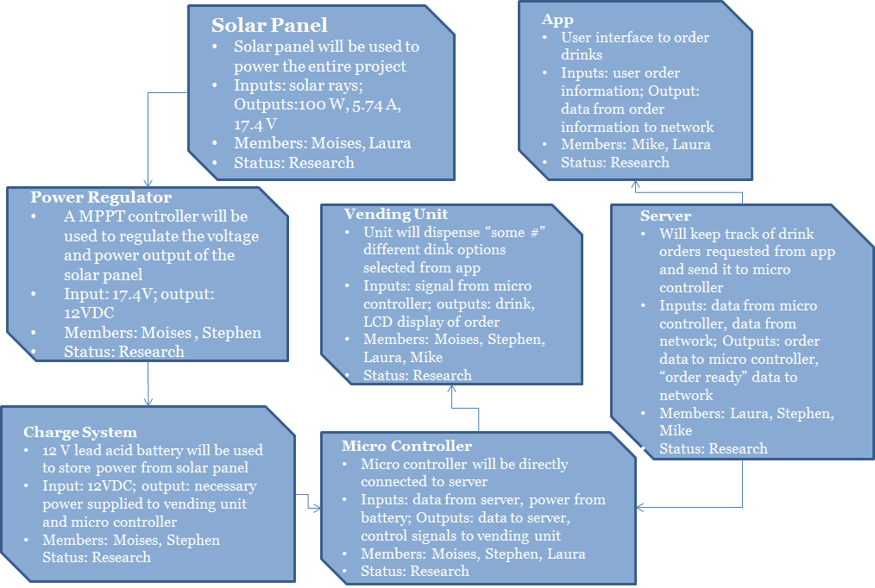Figure1: Block Diagram

**5.**

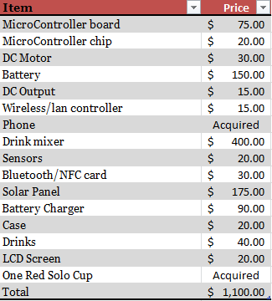

Figure 2: Projected Budget

**6.**  During this earliest state of the project, a lot of our time will be dedicated on research in order to grasp the basic idea of each component of the function block diagram. On a weekly basis, every single member on the group will provide an update of their work to the rest of the members so everyone knows how the project is progressing.

**Summer**

· Research on new and improved solar panels

· All classes, functions, procedures, and methods for programming the phone app

· Research how to communicate the phone app with the drink mixer

· Research embedded systems to be incorporated in the drink mixer

· Research all components needed to design the solar power supply. (Regulators)

· Final schematics of all components connected

· Order all parts chosen for our final design

After research has been completed, the group will start with the building process for the fall semester. Our plan is to have a working phone application this summer so we can focus on building the solar panel in the Fall as well as connecting the app to the system.

Also, all parts that are needed for the project will be ordered before the Fall semester starts, that way the group could start building as soon as the semester begins in order to advance on our projects and gives us plenty time for testing.

**Fall**

· Design projects

· Incorporate all components together

· Test system

· Observe results

· Adjust system if needed

· Prepare Presentation

**7.** Many different ideas were taken under consideration and ultimately lead to the “drink mixer”. This project encapsulates many different technologies to make a cool and fun drink mixer that everyone will love. There are two reasons for powering our machine using solar panels: The first is to show how solar energy can be used in an efficient and simple way; Secondly, many companies offer sponsorships for new ways to use solar energy. In an effort to use modern technology in our design, we decided that this “drink mixer” will be controlled using an app. This feature will give the users the freedom to scroll through mix options rather than going up to the machine to look. Let’s say this machine is used at a picnic or pool party, the app feature will keep from lines forming in front of the machine from people scrolling through options let’s say on a LCD screen that’s attached to it.

This idea however, did not spontaneously come to us but rather was an accumulation of ideas from other opinions. When deciding on what we wanted to do for this project, each member of our group thought of an idea and discussed the pros and cons of each. The initial ideas were an A.I. board game, solar powered lawn mower, automatic drink mixer, and a collision avoidance system for vehicles. A decision matrix was written up to help us decide on the matter and can be seen in Figure 3 below. In the end, it turned into a combination of two ideas, the automatic drink mixer and the solar powered lawn mower. We took the idea of the solar panel and integrated it with the idea of the automatic drink mixer and ultimately lead to the “Solar Powered Drink Mixer”.

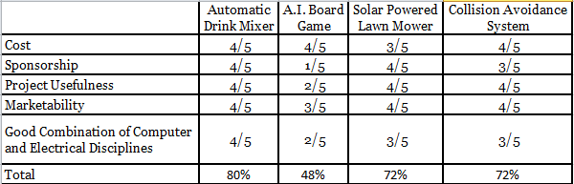  
Figure 3: Decision Matrix